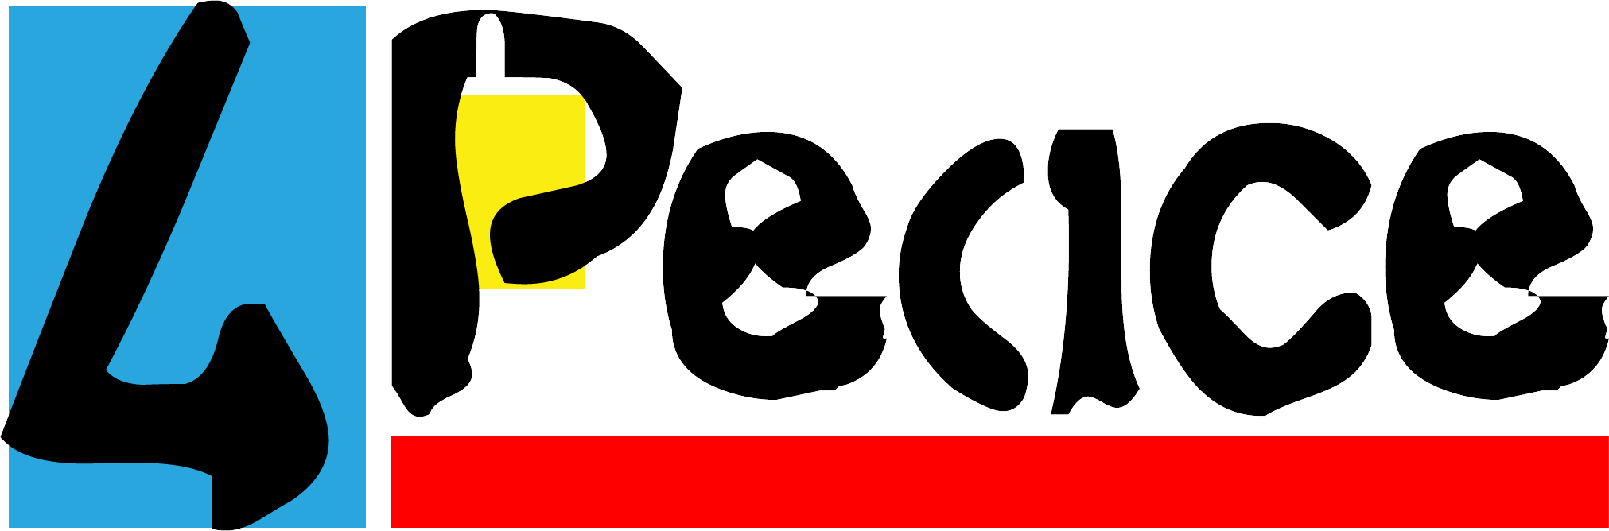

peacecamp - Certificate

This is to certify that you,

________________________________

participated in peacecamp 2016 in Lackenhof and Vienna, Austria, from July 5th to July 15th, 2016.
You
- used a foreign language, English, to communicate and interact with others
- shared your bedroom and dining table with people you did not know before
- shared information about your own and other people’s religion, traditions and customs
- shared personal issues about yourself and your family
- cooperated with others in various workshops
- experimented with different modes of problem solving
- found creative solutions to “mission impossible” tasks
- learned about complex and difficult chapters of history
- debated complex social and political issues
- explored your thoughts and feelings in large group-sessions
- produced and performed a multi media-show for a large audience
- cooperated in creating a peacecamp-film
You now graduate as

Ambassador of Peace

The team of peacecamp 2016.

July 13th, 2016 Evelyn Böhmer-Laufer
Director of peacecamp 2016

